Ch 6: Terrestrial worlds

* 4 t planets (and the moon)
  + Lithosphere
  + Mantle
  + Core
  + Differentiation: dense materials sink; low-density materials rise
    - Can find these layers using seismology (earthquakes)
      * P wave and S wave (can’t go through liquid)
  + Deeper in the planets you go, the hotter it is and higher pressure
* Tidal effect
  + Gravitational potential of moon pulls liquid on the earth, causing bulges
  + Sun also contributes
  + This generates friction, heating the internals of the Earth
* Heating of planets
  + Small planets lose heat faster
* Magnetic field
  + Earth/Mercury have significant magnetic field
* 4 processes to effect surfaces
  + Impact cratering
    - More important early on
  + Tectonism
  + Volcanism
  + Erosion
    - These three smooth the surface
* Impact cratering
  + Can use cratering to date surfaces
  + Hypothesis for formation of moon
    - Collision between earth and mars like structure
* Tectonism
  + Convection moves the plates around

Ch 7: Atmospheres of terrestrials

* Primary
  + Formed with the formation of the planets
  + Terrestrial planets lose this due to not having enough gravity
* Secondary
  + Created through
    - Accretion
    - Volcanism
    - Comet impacts
* Temperature of these atmospheres
  + Mainly determined by:
    - Distance to the sun
    - Albedo
    - Greenhouse effect
      * Greenhouse gases (water, co2) absorb sunlight, reflect it off the surface, and reflect it back to the surface
      * Very evident on Venus
* Earth
  + Mainly nitrogen
  + Has oxygen, which other planets do not have (a result from life on earth)
* Layers on Earth
  + Troposphere
    - Temperature decline with altitude
  + Stratosphere
  + Mesosphere
  + Thermosphere
* Magnetosphere
  + Shields earth from solar wind
* Movement of atmosphere
  + Coriolis effect (rotation speed), convection currents, Hadley circulation

Ch 8: Giant planets

* Find size of these through stellar occulation
* Mass by looking at their orbiting moons or satellite deflection
* Gas giants
  + Jupiter
  + Saturn
* Ice giants
  + Uranus
  + Neptune
* No solid surfaces, just clouds
  + Less dense then terrestrial planets
* Rotation
  + Very fast rotation for all, making them oblate (stretched sphere)
  + Give horizontal bands in atmosphere (seen easily in Jupiter and Saturn)
* Angle of rotation
  + Effects seasons
    - Jupiter (no season)
    - Saturn/Uranus (similar to earth)
    - Neptune (crazy extreme seasons)
* Winds
  + Varying with latitude
    - Jupiter/Saturn have strongest winds
* Layers
  + Very large, deep atmoshperes, with a liquid/solid core
* Magnetic fields
  + Very large
  + Some aligned, some not
  + Create radiation zones
* Rings
  + Easily seen on Saturn

Ch 9: Small bodies

* Dwarf planet
  + Pluto for example
  + Highly elliptical orbits
* Planet description
  + Pulls itself into a round shape
  + Clears an area around its orbit
  + Orbits a star
* Moons
  + Most of them are giant’s moons
  + Craters reveal age
  + Some have atmospheres, lakes, geological activity
* Asteroids
  + Most found in asteroid belt
  + Near-orbit asteroids = have orbits that cross that of Earth
  + Small rocky objects
* Comets
  + Icy objects
  + Origin
    - Kuyper belt
    - Oort cloud surround solar system
  + Short period comet
    - Less than 200 years
    - Near elliptic plane
  + Long period
    - From Oort cloud
    - Extremely ecliptic orbit
  + Compositon
    - Ion tale (away from the sun)
    - Dust tale
    - Coma
    - Nucleus
  + Meteorites: pieces of rock that have landed on Earth

Ch 10: Stars

* Temperature
  + Color tells temperature (blue high, red low)
* Black body radiation
  + 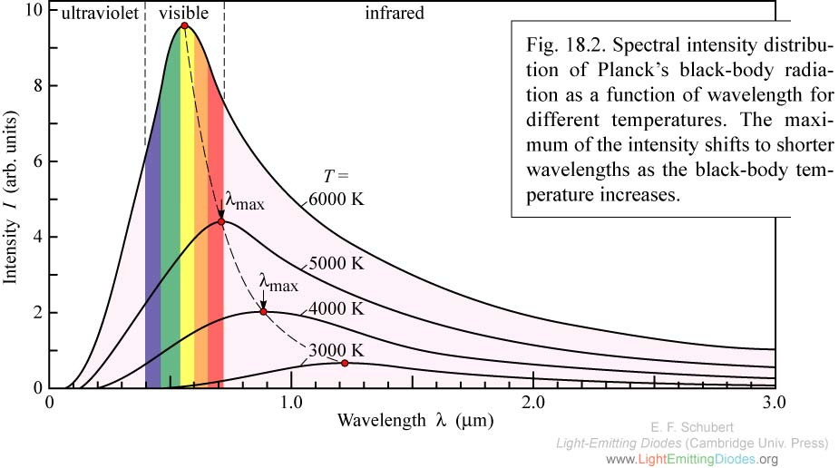
* Classification of stars
  + OBAFGKM
    - Sun is a G2 star
* Brightness
  + Depends on luminosity and distance
    - Dim star could have low luminosity or be far away; bright star could be close or have high luminosity
* Distance
  + Parallax (two thumbs up, close either eye)
    - Greater the parallax, smaller the distance
  + Parsec
    - One arc-second
    - 1 arc-minute = 1/60 of a degree
    - Parsec = 3.26 light year
* Size
  + Luminosity and temperature
* Mass
  + Look at effects of gravity
  + Center of mass
* Chemical composition
  + Emission/absorption lines
  + When electrons change state, they emit emission lines
    - Emits a photon and drops to a lower energy state, losing energy
    - Photons energy is equal to the energy difference between the two levels
  + Absorption
    - An electron absorbs energy of a photon to go to a higher energy level
  + Stars can have several emission/absorption lines depending on their state
  + Classify by absorption lines
* Size (radius)
  + L = 4piR^2T^2
* H-R diagram (Hertzsprund and Russel diagram)
  + Plot of luminosity vs temperature
  + Majority lie on a line, the main sequence
    - More massive main sequence stars are large, luminous, and hot
* Globular cluster
  + Contains millions of stars
  + Used to study stellar evolution

Ch 11: The Sun

* G2 star
* Structure
  + Giant sphere of hot gas, with no solid surface
  + Very stable (rate of energy loss = rate of energy produced)
    - Hydrostatic equilibrium
  + Density, temperature, pressure increase towards the center
* Proton-proton chain
  + Nuclear fusion
  + Hydrogen turning into helium
    - E = mc^2
  + Energy found in stars
* Methods of heat moving
  + Radiation
  + Convection
    - Energy from core takes 100,000 years to reach surface